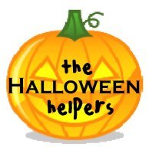

Help Us Collect Previously Enjoyed Halloween Costumes for Children in Need!

Dates of Collection:___________________________

Location: ___________________________________

We are seeking the following types of Halloween costumes:

• Clean, gently-used costumes
• Infant through adult sizes
• Individually bagged
• Labeled with the following information: gender, size, type
• Complete costumes only (What is a pirate without his eye patch? A princess without her crown?)

For more information, visit:
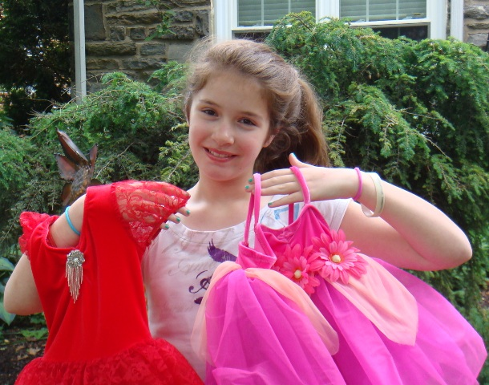
TheHalloweenHelpers.com.
About The Halloween Helpers
The Halloween Helpers was conceived in 2008 by then 11-year-old Emma Rose Shapiro while sorting through costumes from years past. The young community servant realized that there are children fortunate enough to get a new costume every year and those who do not even get one in their brief childhood. Emma's goal is to enlist children who outgrow or become disinterested in previous years' costumes and share them with kids in our own community who would not typically receive them. Through this one simple effort, Emma’s ultimate objective is to provide children with life-long memories, develop self-worth, and “level the playing field” among all children.

