

Help Us Collect Previously-Enjoyed Halloween Costumes for Children in Need!

How you can help:

Hold a costume drive at your school, business, camp, scout troop, religious group, special event or organization. We’ll provide the collection box and signage. Logos, photos and flyers are available on our Web site, TheHalloweenHelpers.com.

Volunteer: Help distribute and/or retrieve costume collection boxes, sort and label costumes, or help out at our mid-October costume distribution events.

Collect just a few costumes from friends and family: Halloween costumes must be clean and gently-used; infant through adult sizes; individually bagged; labeled with the following information: gender, size, type; complete costumes preferred (What is a pirate without his eye patch? A princess without her crown?). Check our Web site for collection locations, dates and times.

We are open to any and all ideas!

E-mail us: TheHalloweenHelpers@gmail.com
Or visit our Web site: TheHalloweenHelpers.com
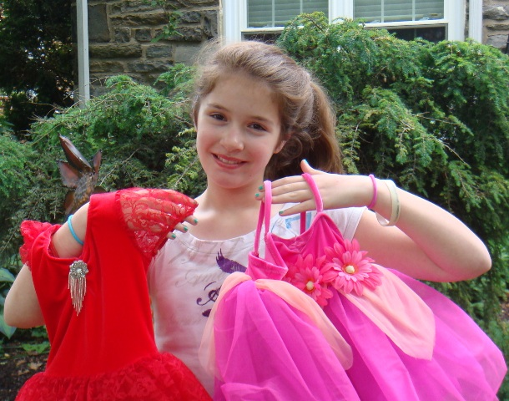
About The Halloween Helpers
The Halloween Helpers was conceived by 11-year-old Emma Rose Shapiro while sorting through costumes from years past. The young community servant realized that there are children fortunate enough to get a new costume every year and those who do not even get one. Emma's goal is to enlist children who outgrow or become disinterested in previous years' costumes and share them with kids in our own community who would not typically receive them. Through this one simple effort, Emma’s ultimate objective is to provide children with life-long memories, develop self-worth, and build stronger communities.

About The Halloween Helpers
The Halloween Helpers was conceived in 2008 by then 11-year-old Emma Rose Shapiro while sorting through costumes from years past. The young community servant realized that there are children fortunate enough to get a new costume every year and those who do not even get one in their brief childhood. Emma's goal is to enlist children who outgrow or become disinterested in previous years' costumes and share them with kids in our own community who would not typically receive them. Through this one simple effort, Emma’s ultimate objective is to provide children with life-long memories, develop self-worth, and “level the playing field” among all children.

